RESUME

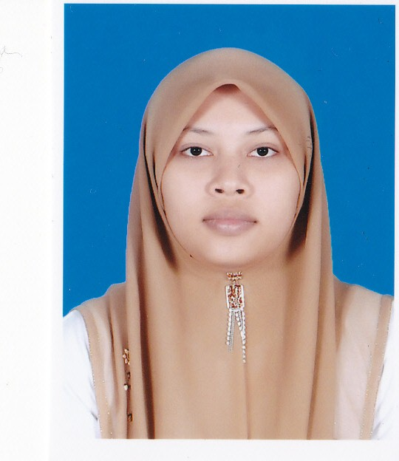

NUR HIDAYAH BINTI MOHD NOR

ADDRESS
P/S 310 Kampung Lembah, Gaal,
16800 Pasir Puteh,
Kelantan.

CAREER OBJECTIVE
To become a successful person in any field.

PERSONAL DETAILS
Ic number : 911126-03-6058
Age : 24 years
Birth date : 26 november 1991
Birth at : Hospital Machang Kelantan
Marital status : Single
Gender : Female
Citizen : Malaysia
Contact number : 0139054164
E-meil : nuda2611@gmail.com

EDUCATION BACKGROUND
Year School/institution Grade

2013 – now UNIKL BMI Bachelor
(Bachelor in Engineering Technology (CGPA:2.95)
Hons in (Electronic)]

2009 - 2012 Politeknik Kota Bharu, Ketereh, Diploma
Kota Bharu, Kelantan Darul Naim. (CGPA:3.6)
(Diploma Kejuruteraan Elektronik)

2008 Sek. Men. Keb. Jeram, SPM
16800 Pasir Puteh, Kelantan Darul Naim. (4A, 1B, 2C, 2D)

WORKING EXPERIENCE

- PTPTN (JUN 2012 – NOVEMBER 2012)
- Technician at NSW electronic company (JUN 2010 – DICEMBER 2010)

CO – CURRICULUM ACTIVITIES AT IPT

- Ahli Jawatankuasa Pelajar Kamsis (JPK), 2010
- Counselling club member, 2010
- Ketua Biro Akademik Persatuan Pelajar Kejuruteraan Elektrik, 2010
- Ahli Jawatan Kuasa Kecil Minggu Suai Kenal Sesi Jun 2011
- Kem Kepimpinan Perdana Politeknik Kota Bharu, 2011
- Setiausaha Persatuan Pelajar Kejuruteraan Elektrik, 2011
- Ahli Kelab Pembimbing Rakan Siswa Politeknik, 2011
- Kursus PIC, 2011
- Ahli Persatuan Pelajar Kejuruteraan Elektrik, 2012
- Seminar Keusahawanan, 2012
- Kursus Taha@U, 2012
- ERICSON courses, 2012
- LabVIEW training, 2015

SKILLS
- Computer
- Good in computer application (Microsoft Word, Excel and Power Point,Publisher & Internet)
- Good in electronic application (multisim, pspice, mathlab, programming c++, integrated circuit programming PIC, proteus, keil, microwind, weka, fuzzy, quartus II, DE2 board, LabVIEW, National Instrument MyRIO)

- Technical
- Good in (circuit connection, integratel circuit connection, wirering)

- Interpersonal
- Carismatic person.
- Hardworking person.
- Creative and inovative person.

- Language (scale 1 – 10 )
- Bahasa Malaysia (10)
- English (7)

AWARDS AND ACHIEVEMENTS
- Dean list for semester (1, 2, 3, 6) at politechnic Kota Bharu.

REFERENCES:

Puan Rossliza bt Kamarudin, Encik Azman b Mohd Nor
Pengawai, Pengurus,
Perbadanan Tabung Pendidikan Tinggi Tingkat 6, Bangunan Medan Mara, Nasional (PTPTN) Jalan Raja Laut, Wisma Chase Perdana 50609, Kuala Lumpur,
Off Jalan Semantan, Damansara Heights No. Tel :019-2048504.
50490 Kuala Lumpur
No. Tel :019-3388504
Email : rossliza@ptptn.gov.my

